IS-665
Data Warehousing, Data Mining & Visualization
Association Rules Project

BY
Alfa Yeasmin

Executive Summary
Overview and project aim: In this paper we use a bank dataset which is based on a campaign to identify customers who are willing to subscribe a term deposit. The bank database has been shown that 5 % of customers who positively respond to the campaign.
Outline of processing and planning Stage: IBM SPSS Statistic and IBM SPSS Modeler software have used for the Data mining tasks. Data mining tasks are preparing data for mining, exploratory data analysis, clustering model and association rules model.
Outline of testing: At the beginning decide to discard 5 variables within 21 variables which are based on social and economic context because we need to process the experiment in a reliable way to determine some good solutions for the goal. The data set does not have missing values but provides outlier within variables. Choosing to keep outlier because many other information can be lost and having more data is almost always better. Performing a descriptive analysis but could not find useful information. Resolve correlation issues and eliminate 3 numeric variables. Checking normality and reducing skewness in order to get best result on the model. Applying clustering analysis in order to identify quality of variables, describe the patterns and generate new variables to apply on the predictive model. . Also, apply to discover useful records.
Summary of final results: Using association rules we can see that customers who are married, employed in admin position, taking loan, have university degree and do not have enough credit they most likely response “yes” to the campaign. However, customer who retired they are most also response “yes” to the campaign.

Understanding of business goal in Data mining:
A campaign is usually launched to be a specific goal in a company or organization which can create awareness about the company and its product, service, politician, social issues and causes to facilitating more sales. In this paper we use a bank dataset which is based on a campaign to identify customers who are willing to subscribe a term deposit. In this case we use data mining techniques which are a process of discovering meaningful patterns and rules in order to improve a company’s business. The bank database has been shown that 5 % of customers who positively respond to the campaign. In this paper we will see how data mining can help to identify uncover information based on these customers respond in order to make a better business decision in the future.
Understanding Dataset and Data mining tasks:
Attributes Information:
This project is to identify useful description among the attributes of the bank dataset composed of 21 attributes where one attribute which is “y” with partition information that indicates customers’ yes or no response. The dataset contains 37,004 records of information which are related to financial customers that have been targeted for a telemarketing campaign. List of the attributes (under name) and types of attribute are as follows:
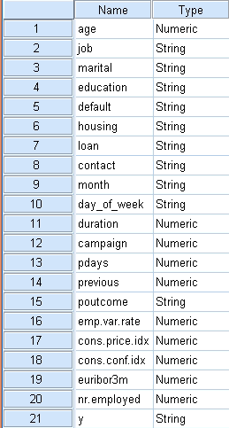
Following above attributes type are String same as categorical or nominal. However, the campaign main purpose is to whether the customer subscribed for the term deposit product or not based on the response we see 95 % of the customer response no and 5 % of response yes. Below is the figure of response (yes or no):

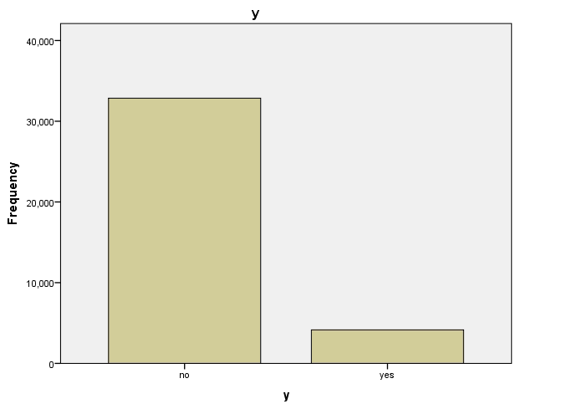
Why a decision has been made to discard some attributes:
The dataset contains five social and economic context attributes; they are emp.var.rate (employment variation rate), cons.price.idx (consumer price index), cons.conf.idx (consumer confidence index), euribor3m (euribor 3 month rate) and nr.employed (number of employees). These attributes are more likely related to a customer social network and economic condition which are not consistent to give us a good solution for the business goal. We need to process the experiment in a reliable way to determine some good solutions for the goal.
Data mining tasks:
Data mining tasks are technical activities which are based on a business goal. IBM SPSS Statistic and IBM SPSS Modeler software have used for the Data mining tasks. Following tasks are involving to the business goal.
(1)Preparing data for mining
(2)Exploratory data analysis
(3)Finding clusters (unsupervised learning model)
(4)Association Rules (supervised learning model)
(1)Preparing data for mining: We need to preprocess the data because most of the raw data is contains un-preprocessed, incomplete and noisy in database. For example, the database may contains fields that are obsolete or redundant, missing values, outliers, data in a form not suitable for the data mining models and values that is not consistent with common sense or policy. Data preprocessing involve in the following tasks:
- Data cleaning and missing values: We clean the data as of classifying unusual values such as marital stored as S or single. In this case we have to remove the S as single. But we have not seen any unusual values by using descriptive statistic (have not seen on each variable frequency tables).
However, the pattern of the missing values may be systematic and simply deleting the records with missing values would lead to a biased subset of the data. Therefore, we replace missing values with some constant, mean (for numeric variables), mode (categorical variables), random value from the variable distribution and imputed values. In this case, we have not seen any missing values in the database. The below figures have been shown (Figure 1.1 and Figure 1.2) that there is no missing values within 37004 records on the categorical and numeric variables (columns).
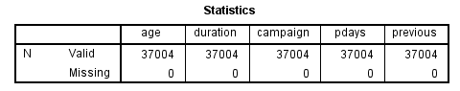
Figure 1.1 no missing values on numeric variables
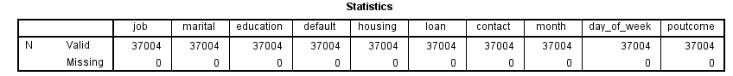
Figure 1.2 no missing values on Categorical variables
- Outliers Identifications: outlier is an anomalous and extreme value when compared with the remaining data. Indentifying outliers is important because they may represent errors in data entry. Even if an outlier is valid data point and not an error, certain statistical method are sensitive to the presence of outlier in the database and may deliver unreliable results. As a result, we examine values of numeric variables. We use certain statistical method such as mean, median and mode but these are very sensitive for outliers. Also we use graphical method such as histogram and two-dimensional scatter plot to identify outliers. However, we use numerical method such as Z-Standardized and Inter-quartile Range (IQR) to identify outliers. In this case, we use IQR and Histogram methods to identify outliers because these methods less sensitive than others.
Calculation of IQR to identify outliers: To identify the outliers we take lower quartile which is called Q1, upper quartile which is called Q3 and difference between two quartiles which is called IQR. IQR=Q3 –Q1 representing the spread of the middle 50% of the data. Values are defined as outlier if:
Lower than Q1-1.5x (IQR) or
Higher than Q3+ 1.5x (IQR)
The figure 1.3 shows:
Q1= 32 (25 percentiles)
Q3= 47 (75 percentiles)
IQR=47-32=15
Outlier determine Lower than Q1-1.5 x IQR= 9.5; or
Outlier determine Higher than Q3 +1.5x IQR =69.5
The figure 1.4 shows that values more than 69.5 and there are no lowest values less than 9.5. As a result of this, customers who have aged more than 70 they determine as outlier.
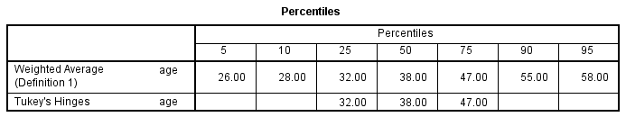
Figure 1.3 percentiles of Age
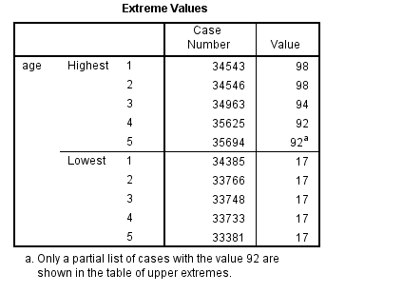
Figure 1.4 Age Extreme values of Age
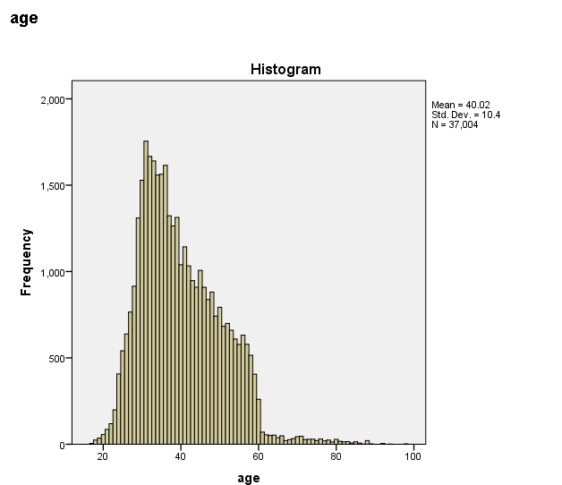
Figure 1.5 Histogram of Age
Calculation of IQR to identify outliers:
The figure 1.6 shows that (contact duration) percentile table:
Q1=102.00 (25 percentiles)
Q3=319.00 (75 percentiles)
IQR=Q3-Q1=217.00
Values are defined as outliers if:
Outlier determine Lower than Q1-1.5 x IQR= - 223.5 or
Outlier determine Higher than Q3+1.5 x IQR= 542.5
The figure 1.7 shows more than 542.5 values and they are disappeared if we look at the figure 1.8. These values are hard to see because we might have very few on the database. Also, there are no less than -223.5 values if we look on Extreme values table and the Histogram.
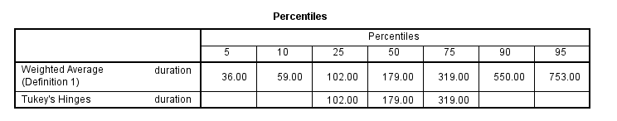
Figure 1.6 percentiles of duration
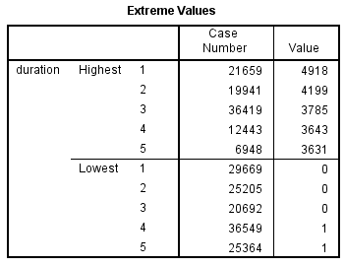
Figure 1.7 Extreme values of duration

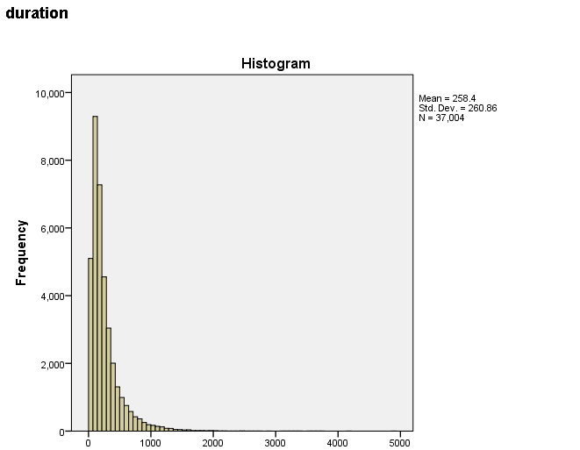
Figure 1.8 Histogram of duration

Calculation of IQR to identify Outliers:
The figure 1.9 shows:
Q1=1.00
Q3=3.00
IQR =Q3-Q1= 2
Values are defined as outliers if:
Outlier determine lower than Q1- 1.5 x IQR= -2
Outlier determine higher than Q3+ 1.5 x IQR= 6
The figure 1.10 shows that there are values more than 6 and also values are disappeared if we look at the histogram. However, there are no values less than -2.
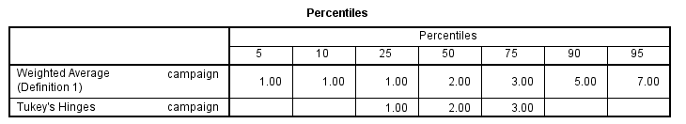
Figure 1.9 Percentiles of Campaign

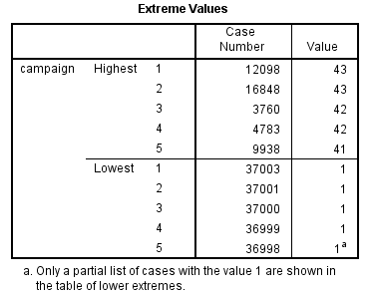
Figure 1.10 Extreme values of Campaign

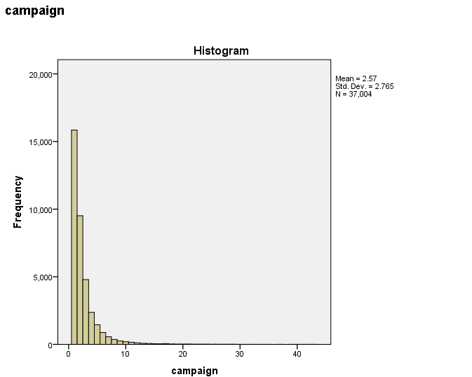
Figure 1.11 Histogram of Campaign

Calculation of IQR to identify outliers:
The figure 1.12 shows (number of days that passed by after the client was last contacted from a previous campaign):
Q1=999
Q3=999
IQR= Q3-Q1=0
Values are defined as outlier if:
Outliers determine lower than Q1- 1.5 x IQR=999
Outliers determine higher than Q3+1.5 x IQR=999
The figure 1.13 shows that there is no values more than 999 (means client was not previously contacted) but has very few portions of 0 values if we look at the table and histogram.

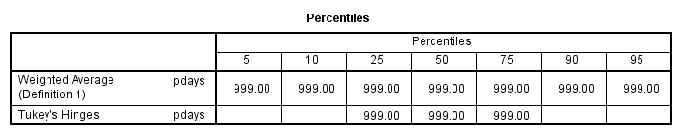
Figure 1.12 Percentiles of pdays
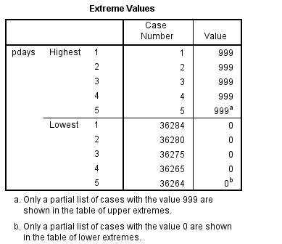
Figure 1.13 Extreme values of pdays

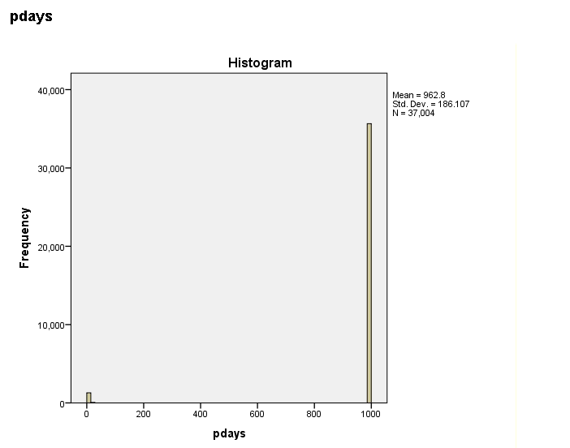

Figure 1.14 Histogram of pdays

Calculation of IQR to identify outliers:
The figure 1.15 shows (number of contacts performed before this campaign for the client):
Q1= 0.00 (25 percentiles)
Q3= 0.00 (75 percentiles)
IQR=Q3-Q1=0.00
Values are defined as outliers if:
Outlier determine Lower than Q1-1.5 x IQR= 0.00 or
Outlier determine Higher than Q3+1.5 x IQR= 0.00
The figures 1.16 and 1.17 shows that values are more than 0.00 but no less than 0.00.
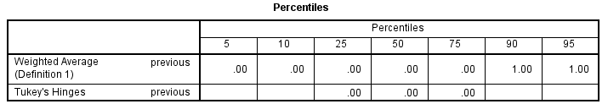
Figure 1.15 Percentiles of Previous
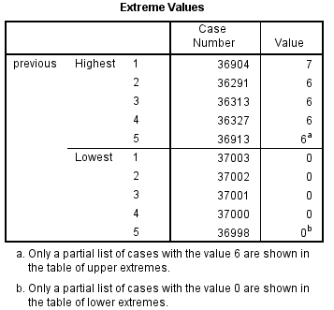
Figure 1.16 Extreme Values of Previous

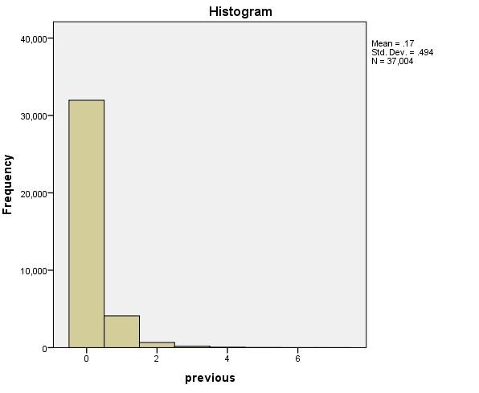
Figure 1.17 Histogram of Previous
Decision to deal with outlier:
Deciding to keep outliers because we see very few portions of extreme values appear on the database using statistical analysis. However, outliers may draw attention to valid business that illustrates an unusual bit significant event. In this project our intention is to use clustering model where we try to get information based on these variables. So removing outliers is a waste because many other information can be lost and having more data is almost always better. So we need to deal with this issue very carefully. We will see the result as we proceed with outliers to the clustering model.
(2) Exploratory Data Analysis: Exploratory Data Analysis (EDA) involves large quantities of data to produce meaningful results. The EDA can be approached with a hypothesis testing. In hypothesis testing, the goal is to use data to answer questions or gain understanding. Hypothesis testing is more scientific and deals with raw data means that statistical methods such as T-test need to be administered to state the answer to the question with 95% statistical significance. In this paper we can see how hypothesis testing answers the question and approve or disprove the answer statistically.
Statistic Testing: it has two parts one is descriptive statistics means it is a type of statistical analysis focused on describing, summarizing, or explaining a set of data and another one is inferential statistic means it focus on estimation, hypothesis testing, point estimation and inferential estimation based on sample data (the data that we describe on descriptive statistic).
- Descriptive Statistic: We assume customers who are contacted a number of times previously to the bank before the campaign they are response positively (response yes). The figure 1.18 shows that mean of no, .13 and yes .49. It indicates that there might a possibility to prove the assumption. Also, the histograms (figure 1.19 and figure 1.20) show that customers yes(y=yes) response more than no(y=no). However, the variable is not normally distributed (variable as a symmetric bell-shape graph) which is represented by Skewness (4.0, 2.1) and kurtosis (24.4, 5.4). The variable would consider as a normal distribution if the values fall on range between -1 and 1. Therefore, we need to normalize the variable as we go through the process.
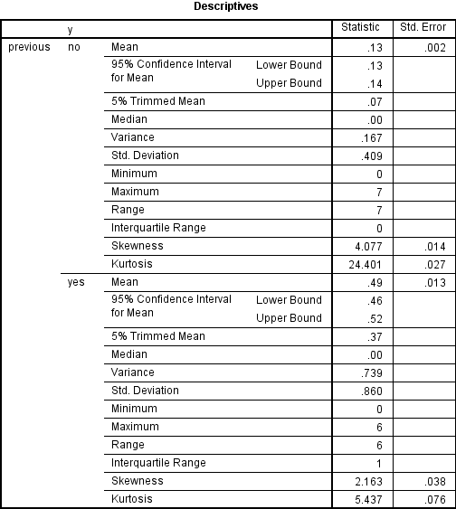
Figure 1.18 Descriptive Statistic of Previous on Y
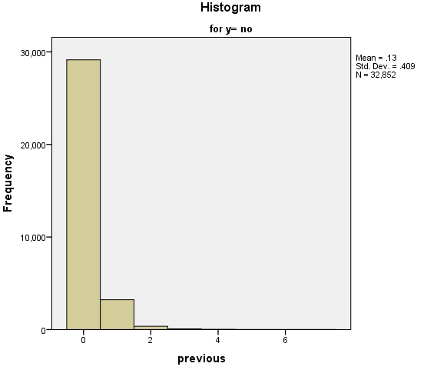
Figure 1.19 Histogram of Previous y= no
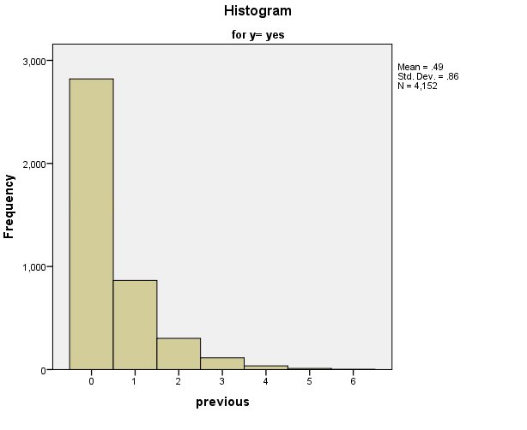
Figure 1.20 Histogram of Previous y= yes

(2) Inferential Statistic: Hypothesis testing plays a fundamental role in Inferential Statistic. At first we need to state relevant null and alternative hypotheses in order to test the hypothesis. Most importantly, the hypotheses depend on p-value and alpha value. If p-value is less than or greater than the required significance level (p-value < 0.05 or p-value > .05), then we say the null hypothesis is rejected (p-value < 0.05) or accepted (p-value > 0.05) at the given level of significance. Rejection or acceptable of the null hypothesis is a conclusion. Our null hypothesis is: Customers who are contacted a number of times previously before the campaign they response positively. Alternatively, customers who are contacted a number of times previously before the campaign, their response significantly different.
The figure 1.22 shows p-value of .001 (under sig. two-tailed) less than alpha value of .05 that specifies the customer responses significantly different although they contacted a number of times previously to the bank. However, the mean (.49) of yes was greater than the mean (.13) of no on the data and there was a possibility to prove the hypothesis but the null hypothesis strongly rejects because of the sample size. The figure 1.21 shows unlike sample of size (4152 on yes and 32852 on no) from the population (37,004 populations) thus the null hypothesis significantly rejects which is indicates the mean of yes and no are same.
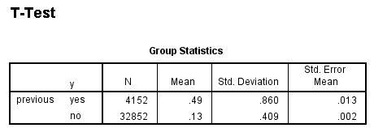
Figure 1.21 T-test of Previous on Y
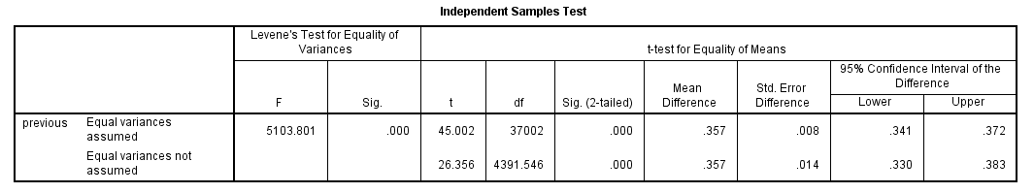
Figure 1.22 Independent Sample test of Previous on Y
Correlation among numeric variables: Two variables are correlated when they are related through a possibly unknown relationship. When two or more variables are correlated we need to discard one of them otherwise they will influence the model as double contribution. The quantity r, called the linear correlation coefficient which is measures the strength and the direction of a linear relationship between two variables. It is also referred as a Pearson correlation coefficient. The value of r is such that -1 < r < +1. The + and – signs are used for positive linear correlation and negative linear correlations. The r value +1 indicates relationship between two variables strongly positive and if one variable increases the other variable will increase as well. Also, the r value -1 shows the opposite results means if one variable decrease the other variable will decrease eventually. However, if a p value less than alpha value (p < 0.05) then the correction indicates significantly true. In contrast if a p value more than alpha value (p > 0.05) then the correction indicates significantly false.
We can assume that numbers of contact during this campaign depends on the last contact duration to the client. Also, numbers of day (pdays) that passed by after the client was last contacted from a previous campaign depends on number of contacts performed before this campaign for the client. Moreover, we can assume numbers of contact during this campaign also depends on the contact from a previous campaign. However, we see how age correlated with other variables.
Interpretation of the result and discard variables: All variables are strongly correlated with each other (figure 1.23 and 1.24) and they are significantly true (p > 0.05 in correlation case). Deciding to discard duration because the duration was not known before a called performed (if duration=0 then y= “no”); therefore this variable can affect on the output target. Also, pdays and previous both variables are related to previous campaign and in this case we can reject padys. However, we see campaign and previous both variables are strongly correlated with each other but weakly correlated with age. Therefore; we can discard previous variable as well. As a result, remaining numeric variables are age and campaign.
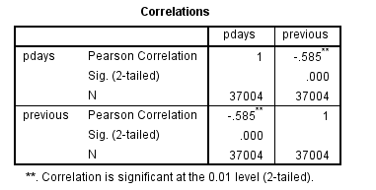
Figure 1.23 Correlations on the numeric variables
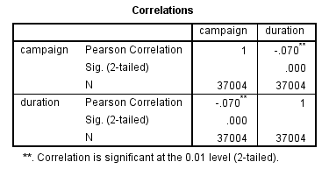
Figure 1.24 Correlations on the numeric variables
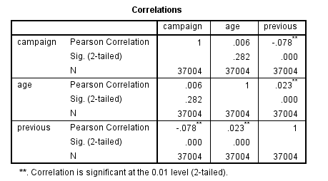
Figure 1.25 Correlations on the numeric variables
Data transformation: variables tend to have ranges that vary greatly from each other. For some data mining algorithms, such differences in the ranges will lead to influences on the results. Therefore; we should normally distribute numeric variables in order to standardize the effect of each variable on the results. To make our data normally distributed, we must first make it symmetric which means eliminating the skewness (shape of variable). There are several methods to transform the data such as min-max normalization, z-score standardization, log transformation and square root transformation. Sometimes min-max normalization and z-score standardization cannot reduce skewness. To eliminate skewness, we apply the log transformation or square root transformation which is reduces skewness even further.
Measuring of skewness (most importantly) or kurtosis and the histogram allow us to understand whether or not a variable follows a normal distribution. Also, the variables will be normally distributed if the variables range falls between -1 and 1. The figure 1.26 shows that age and campaign are fairly distributed. In this case, decide to process the data transformation on campaign variable in order to reduce some skewness. The figure 1.27 shows how skewness reduces after the data transforming. It will be more understandable if we look at the original and normalize data histogram on the variable (figure 1.25 and 1.26).
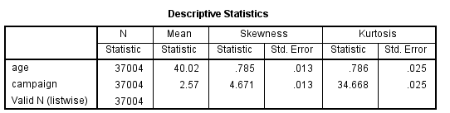
Figure 1.26 summary of skewness on the numeric variables before data transforming
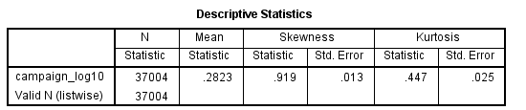
Figure 1.27 summary of skewness on the numeric variable after data transforming
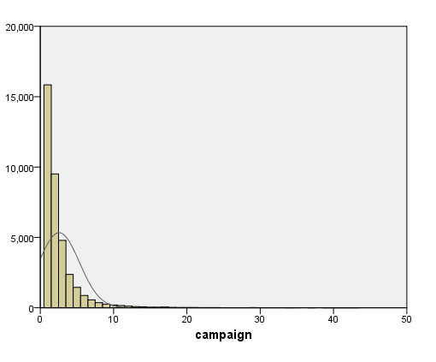
Figure 1.25 Histogram of campaign
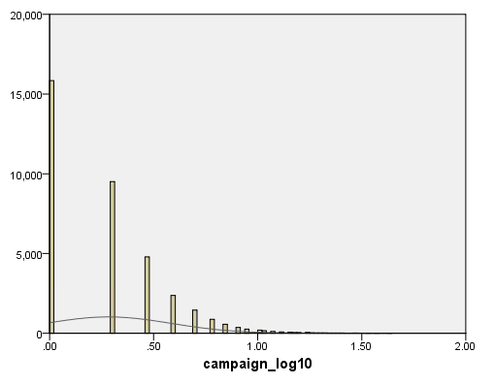
Figure 1.26 Log transformation reduces skewness
Cluster Analysis: It is an unsupervised learning model which is a set of clusters how the cases in dataset are related. There are three clustering methods; they are Hierarchical, Two-step and K-means clustering. In this project, we can see how two-step and K-means clustering methods describe the patterns.
Quality of the variables on Two-step and K-means results: Two-step method has the advantage to determine the proper number of clusters that we can put in the K-mean algorithm. In this case we need to apply Two-step algorithm at first then apply the K-means algorithm.
Some of the categorical variables and numeric variables have been discarded because of providing very poor result while applying two-step algorithm. We can see how five variables with four clusters provide a fair result by using two-step and K-means algorithm (figure 1.27 and figure 1.28). Also, The figure 1.29 shows the importance of variables from high to low priority.

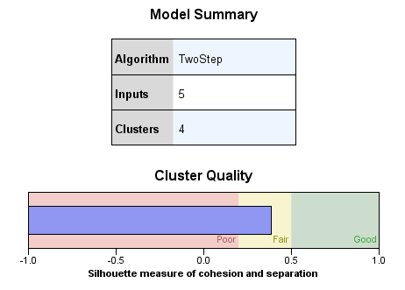
Figure 1.27 Two-step algorithm summary

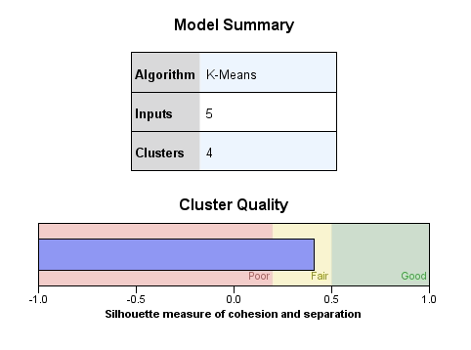
Figure 1.28 K-means algorithm summary
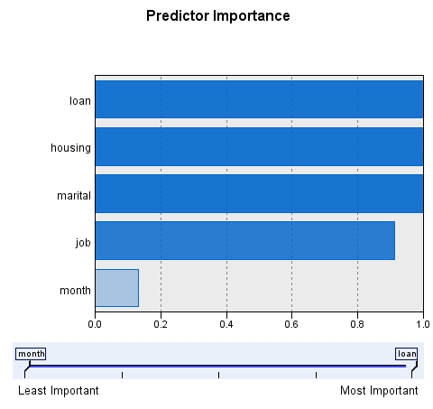
Figure 1.29 Summary of Predictor Importance
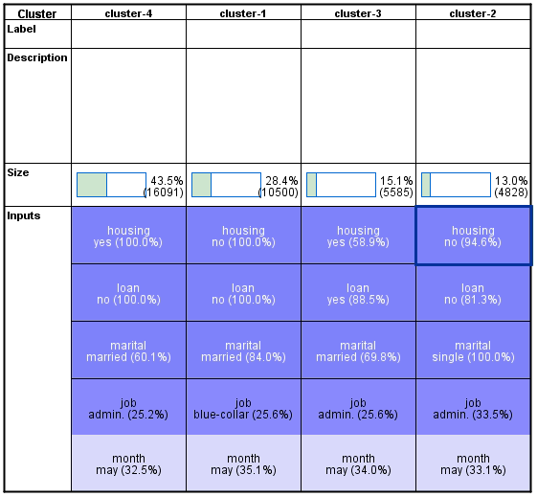
Figure 1.30 Summary of clustering
Interpretation of clustering: The figure 1.30 shows the results of each cluster after applying K-means algorithm. The first cluster which fills 28.4 % contains mostly married customers(84%) who do not have housing loan(100%) or any kinds of loan(100%), occupy blue-collar position() and last contact with the bank on May(35.1%).
The second cluster fills 13% contains mostly single customers(100%) who have housing loan (94.6%) and do not have any kinds of loan(81.3%), occupy admin position(33.5%) and last contact with the bank on May(33.1%).
The third cluster fills 15.1% contains mostly married customers(69.8%) who have housing loan (94.6%) or other kind of loan(88.5%), occupy admin position(25.6%) and last contact with the bank on May(34%).
Most important cluster is the four. It fills 43.5% contains mostly married customers(60.1%) who have housing loan (100%) and do not have any kinds of loan(100%), occupy admin position(25.2%) and last contact with the bank on May(32.5%).
However, we can see customers who are occupying in admin position they are mostly stay connected with the bank (cluster 2, 3 and 4). Also, customers who are single they most likely do not take loan from the bank although they are occupying in admin position. Moreover, customers who married they are most likely to take loan from the bank. The purpose of the loan might be for business, education, car or house equipment. However, most customers stay connected with the bank on the month of May.
Resolving Unbalance data: In our dataset we had 5% “yes” and 95% “no” response; therefore most of records are not useful to the predictive model in order to find useful information who are desire to stay connected with the bank. However, predictive model unable to deal with unbalance data set; therefore we need to balance the dataset before applying the predictive model. Decreasing proportion of y=“no” with balancing value of 0.5 we can balance this dataset (use SPSS Modeler). Following figures are the proportion of records of after and before balancing data set.
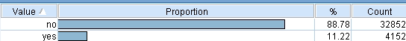
Figure 1.31 Distribution of y before balacing data set

Figure 1.32 Distribution of y after balacing data set

Association rules (Predictive Model): It is a popular method for discovering interesting relations between variables in database. It intends to identify strong rules discover in database using different measures of interestingness.
An association rule generates a form of if antecedent then consequent where antecedent is the condition that must exists in order to generate the result or effect specified in the consequent. Also, association rules include measures of Support and Confidence. Support refers to the percentage records in the training data for which the antecedents are true and confidence is the based on the records for which the consequent are also true. Association rules use an Apriori algorithm and the algorithm employs level-wise search for frequent item sets. In this paper, we can see three Apriori methods of evaluating potential rules. Below are the results of association rules using Apriori methods.
1) Rule Confidence: This is a default method which uses the confidence of the rule to evaluate rules. The figure (1.33) shows that customer who retired they are most likely response “yes” to the campaign. The rules demonstrated by using 5% support with 25% confidence (least confidence percentage able to input). This method is useful because we don't expect to find "common" rule in the common sense of high support/high confidence in these types of data.
Figure 1.33 Summary of an Association rule
2) Confidence Difference: this measure is the absolute difference between the rule’s confidence (posterior) and its prior confidence. Also, it helps to prevent bias where we want to keep the obvious rule. Using this method we can see that clustering analysis helps to generate a useful rule. The following rule including cluster 4 able to give us information that customers who are married, employed in admin position, taking loan, have university degree and do not enough credit they most likely response “yes” to the campaign (figure 1.34). The rule demonstrated by using 5% support with 30% confidence that exactly we wanted by the following figure. Thus, the rule is accepted by this algorithm.
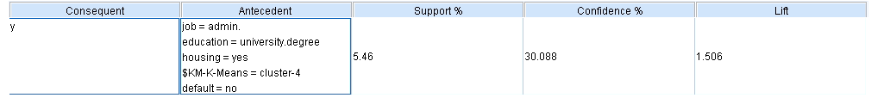
Figure 1.34 Summary of an Association rule

3) Confidence Ratio (lift): this measure is the ratio of rule confidence to prior confidence. If ratio is greater than one then it’s reciprocal. This method is especially good at finding rules that predict rare events. The following rule is providing similar information to the above rule except those customers who are mostly last contacted on the month of May with the bank. The lift (confidence ratio) greater than 1; therefore this rule is accepted by this algorithm (figure 1.35).

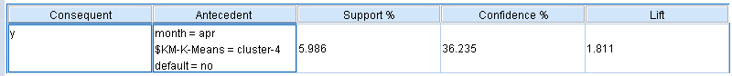
Figure 1.35 Summary of an Association rule

Conclusion: Using the dataset we can see how data mining techniques and tools can help a company to discover uncover information and identify characteristics or attributes of good customers using clustering analysis. Also, we see how association rules helps to collaborate customers’ certain records and provide valuable information. However, appropriate tool and select models based on the bushiness objective can capable to provide best results for the company.

